**Report Title:**  
TK- PAY-MA-R.01 – Altitude and Angle

**Department:**  
Mission Analysis

**Report Date:**  
01/06/2025

**Report Author:**  
Amelia Boccia - Member – Mission Analysis

The task requested computing the satellite’s altitude, viewing angle, and datetime for each useful observation passage.

The requested data were obtained using the Matlab code “*DecayPlot_DistanceCalculation*” that can be found following the path: *Archive > Mission Analysis > Codes and Calculations > DecayPlot_DistanceCalculation*.

The code identifies the useful passages of the satellite over the Campi Flegrei area for the observations. A passage is considered useful if the distance between the satellite's subsatellite point and the center of the Campi Flegrei region is less than half the diagonal of the sensor footprint. The sensor used for this analysis is the Boson640.

To increase the number of useful passages, not only nadir-pointing observations were considered, but also off-nadir observations obtained by rotating the camera's line of sight by an angle ranging from 0 to 25 degrees. For each passage the datetime, the corresponding satellite altitude and the theta angle were computed; with the theta angle defined as the viewing angle, the angle between the nadir direction and the center of the Campi Flegrei area.

No significant modifications were made to the script. The altitude, theta angle, and datetime values were exported from the CF_potente table, which contains all the informations about all useful passages including both daytime and nighttime passages. The data were exported in the excel file that is located within the task output folder, named “*Altitude_Theta_Datetime*”.

In addition to the table, two plots were computed. These plots represent the theta angle and the satellite altitude for each useful passage. Each data point corresponds to the date and time of the observation, which is shown on the x-axis, while the y-axis reports the corresponding value of either the viewing angle or the altitude.

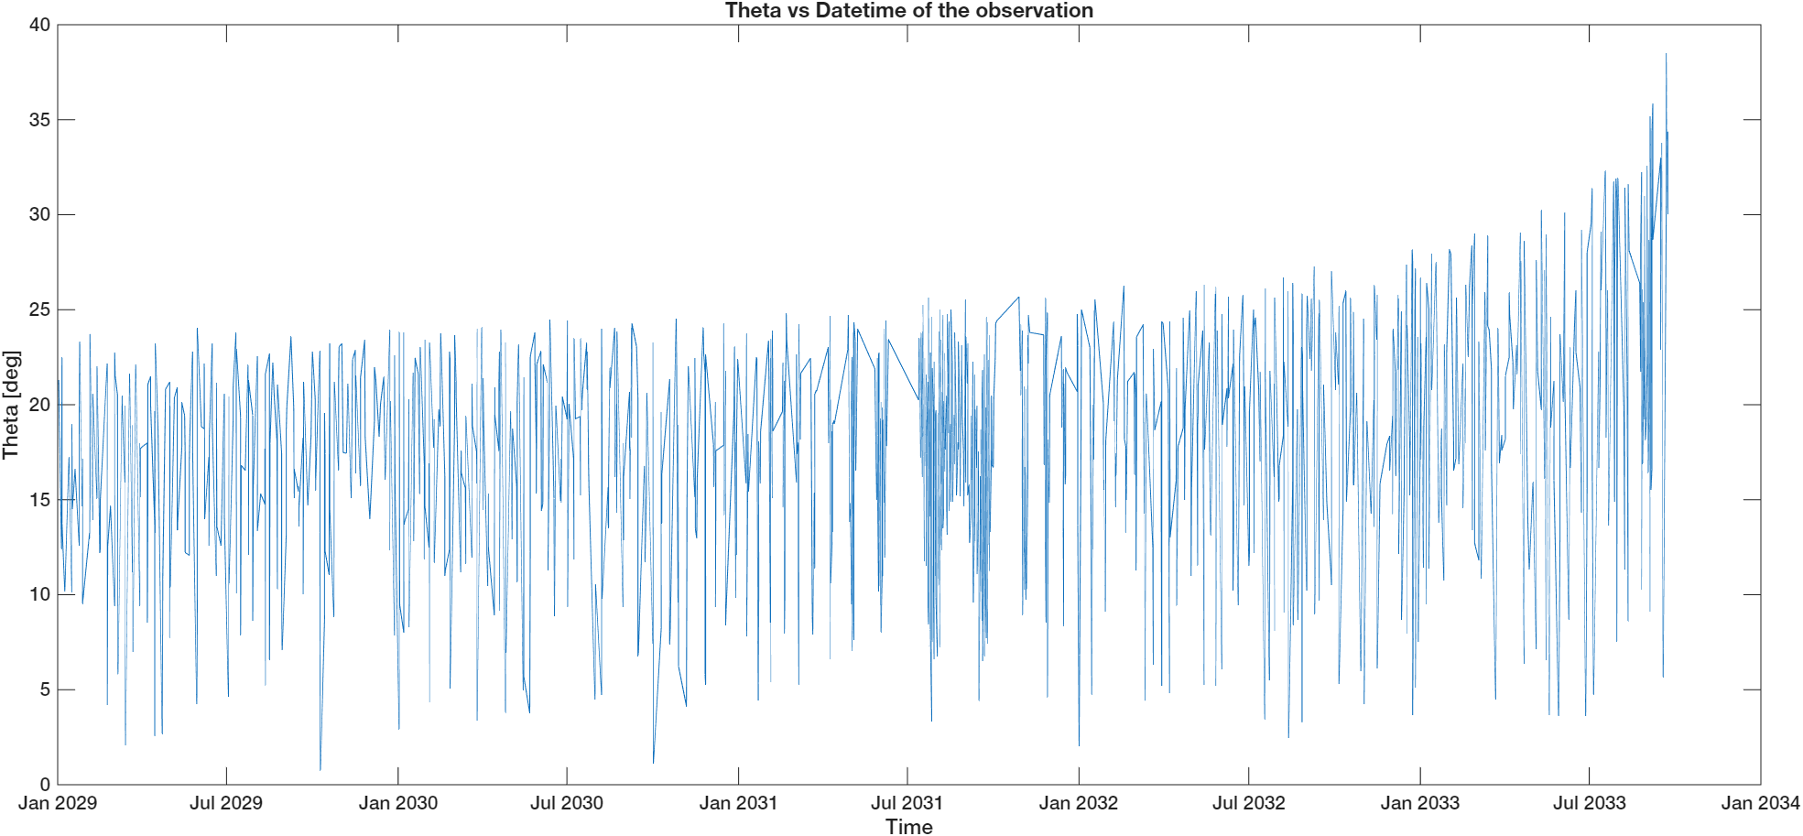

Both plots show non-continuous curves, as the number of useful passages is approximately 15–20 per month. This is due to the fact that the time axis consists of discrete observation points and not of a continuous timeline. As expected, the altitude decreases over time, reflecting the satellite's gradual orbital decay.

Regarding the theta angle, we observe a non-constant, fluctuating trend, with values oscillating between 0° and 25° for most of the satellite's lifetime.  
Towards the end of the mission, as the satellite decays and its altitude decreases, the viewing angle

tends to increase. This is because the distance between the nadir direction and the center of the Campi Flegrei region depends on both the viewing angle and the satellite's altitude

*Amelia Boccia*

*Member – Mission Analysis*

*IGNIS*